I will sing a song for you, my God, with everything I have in me.
But it’s never loud enough! Steven Walkley, Music Minister Email: swalkley@aol.com
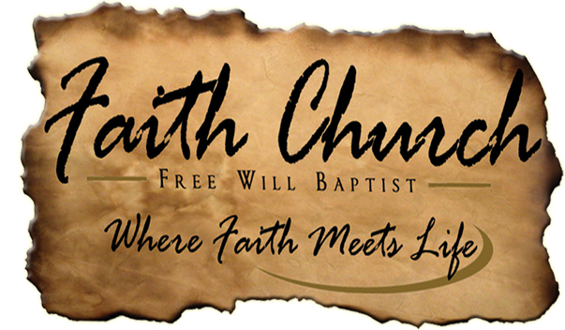
Januar 4, 2015
ORDER OF REHARSAL
1 | What Faith Can Do | Demo & Perf. | Perf. 1x/4 min
2 | Come As You Are | Demo & Perf. | Perf. 1x/4 min
3 | He Knows My Name | Demo & Perf. | Each 1x/8 min
4 | He Is With Us | Demo & Perf. | Each 1x/8 min
5 | Live with Abandon | Perf. | 1x/ 4 min
6 | Overwhelmed | Demo & Perf. | Each 1x/8 min
SOMETHING INSPIRING
“People may hear your words, but they feel your attitude.”

“Everyone has the potential to become an encourager. You don't have to be rich. You don't have to be a genius. You don't have to have it all together. All you have to do is care about people and initiate.”
“Learn to say 'no' to the good so you can say 'yes' to the best.”
-John C. Maxwell

LINEUP | Today | Next Sunday
Ann. | Jordan | -
Praise | My Heart Is Yours | -
Welcome | Pastor Scott | -
Praise |  | -
Break | Kid’s Corner | -
Hymn | - | The Blood Will Never Lose It’s Power
Special | He Is With Us/Overwhelmed | -
Commit | Come As You Are | -
Offering | Offering | -
Outro | Thrive Demo | -
-

Prayer Requests
- Message Today
- Scott and Amy Bee: New home, Travel/Itinerate work
Attendance:___
Cash:_______
Check: ______
Total: _______

Something Funny, silly, or Interesting
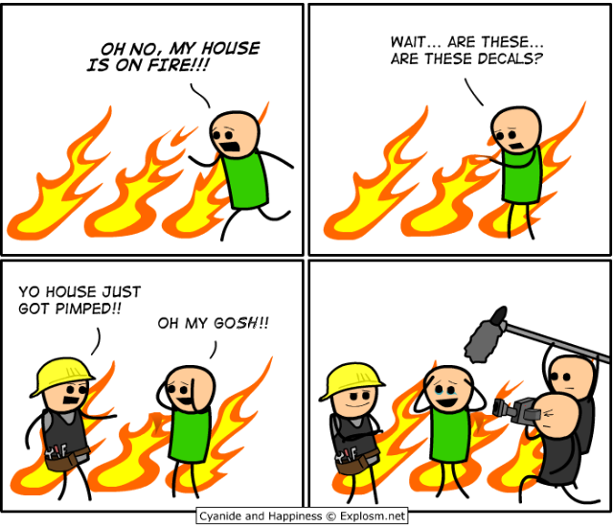

UPCoMING EVENTS
- Church Work Day Jan 24
- Work Night Jan 28
- Super Bowl Sunday Feb 1

SOMETHING FROM SCRIPTURE

SOMETHING FROM SCRIPTURE
“See, I am doing a new thing! Now it springs up; do you not perceive it? I am making a way in the desert and streams in the wasteland.”
Isaiah 43:19 (NIV)

